Given the root of a **complete** binary tree, return the number of the nodes in the tree.

According to [**Wikipedia**](http://en.wikipedia.org/wiki/Binary_tree#Types_of_binary_trees), every level, except possibly the last, is completely filled in a complete binary tree, and all nodes in the last level are as far left as possible. It can have between 1 and 2h nodes inclusive at the last level h.

Design an algorithm that runs in less than O(n) time complexity.

**Example 1:**

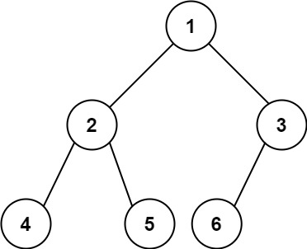

**Input:** root = [1,2,3,4,5,6]

**Output:** 6

**Example 2:**

**Input:** root = []

**Output:** 0

**Example 3:**

**Input:** root = [1]

**Output:** 1

**Constraints:**

* The number of nodes in the tree is in the range [0, 5 * 104].
* 0 <= Node.val <= 5 * 104
* The tree is guaranteed to be **complete**.

/**

* Definition for a binary tree node.

* function TreeNode(val, left, right) {

* this.val = (val===undefined ? 0 : val)

* this.left = (left===undefined ? null : left)

* this.right = (right===undefined ? null : right)

* }

*/

/**

* @param {TreeNode} root

* @return {number}

*/

var countNodes = function(root) {

};

Solution

Approach 1: Linear Time

**Intuition**

This problem is quite popular at Google during the last year. The naive solution here is a linear time one-liner which counts nodes recursively one by one.

**Implementation**

class Solution {

public int countNodes(TreeNode root) {

return root != null ? 1 + countNodes(root.right) + countNodes(root.left) : 0;

}

}

**Complexity Analysis**

* Time complexity : \mathcal{O}(N)O(*N*).
* Space complexity : \mathcal{O}(d) = \mathcal{O}(\log N)O(*d*)=O(log*N*) to keep the recursion stack, where d is a tree depth.

#### Approach 2: Binary search

**Intuition**

Approach 1 doesn't profit from the fact that the tree is a complete one.

In a complete binary tree every level, except possibly the last, is completely filled, and all nodes in the last level are as far left as possible.

That means that complete tree has 2^k2*k* nodes in the kth level if the kth level is not the last one. The last level may be not filled completely, and hence in the last level the number of nodes could vary from 1 to 2^d2*d*, where d is a tree depth.

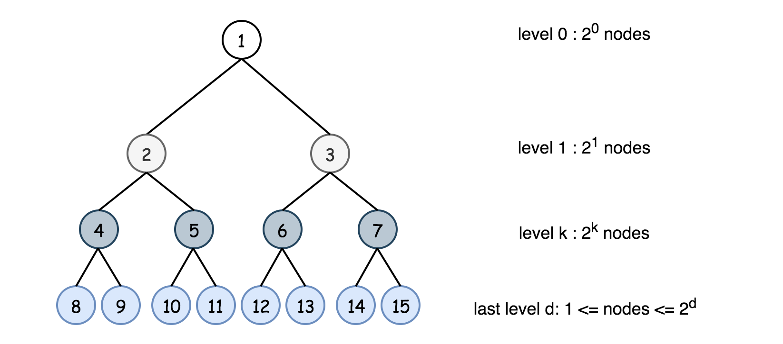

Now one could compute the number of nodes in all levels but the last one: \sum_{k = 0}^{k = d - 1}{2^k} = 2^d - 1∑*k*=0*k*=*d*−1​2*k*=2*d*−1. That reduces the problem to the simple check of how many nodes the tree has in the last level.

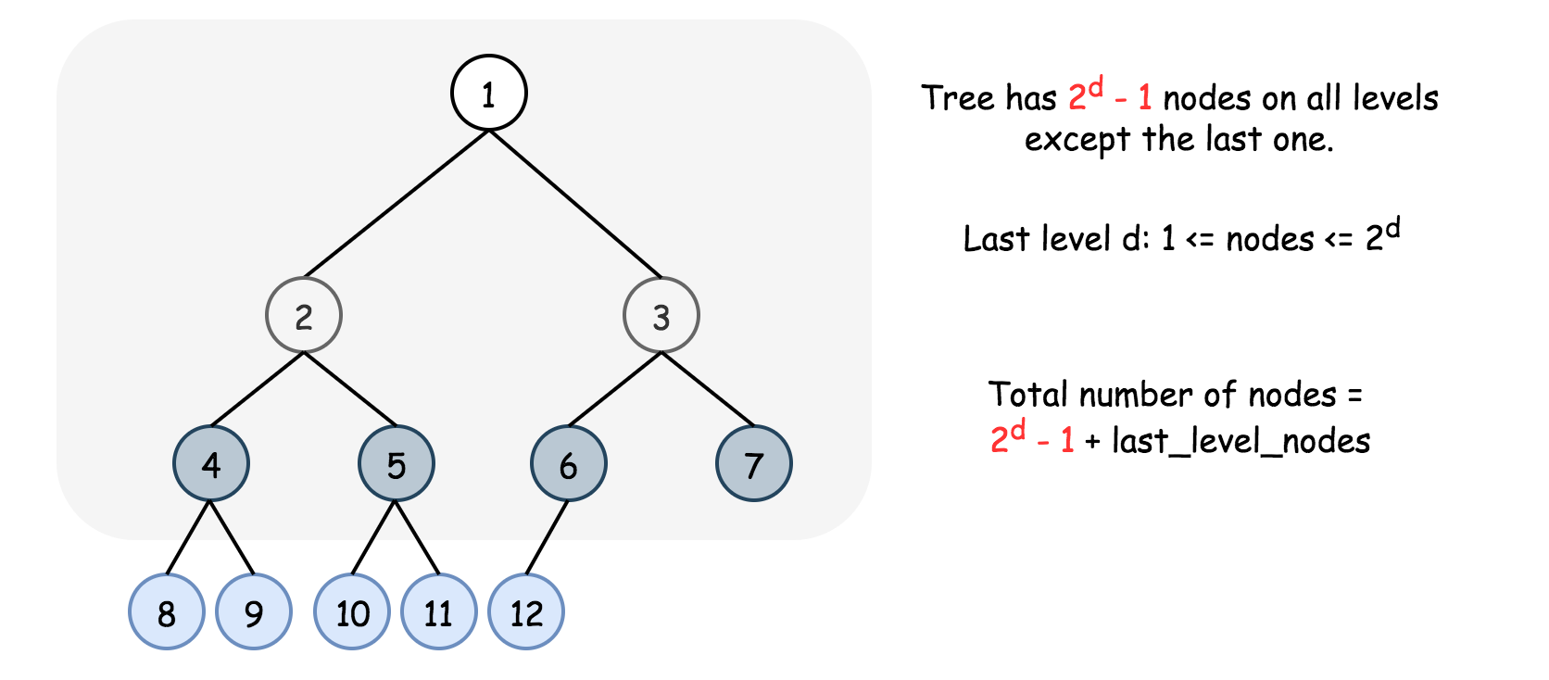

Now there are two questions:

1. How many nodes in the last level have to be checked?
2. What is the best time performance for such a check?

Let's start from the first question. It's a complete tree, and hence all nodes in the last level are as far left as possible. That means that instead of checking the existence of all 2^d2*d* possible leafs, one could use binary search and check \log(2^d) = dlog(2*d*)=*d* leafs only.

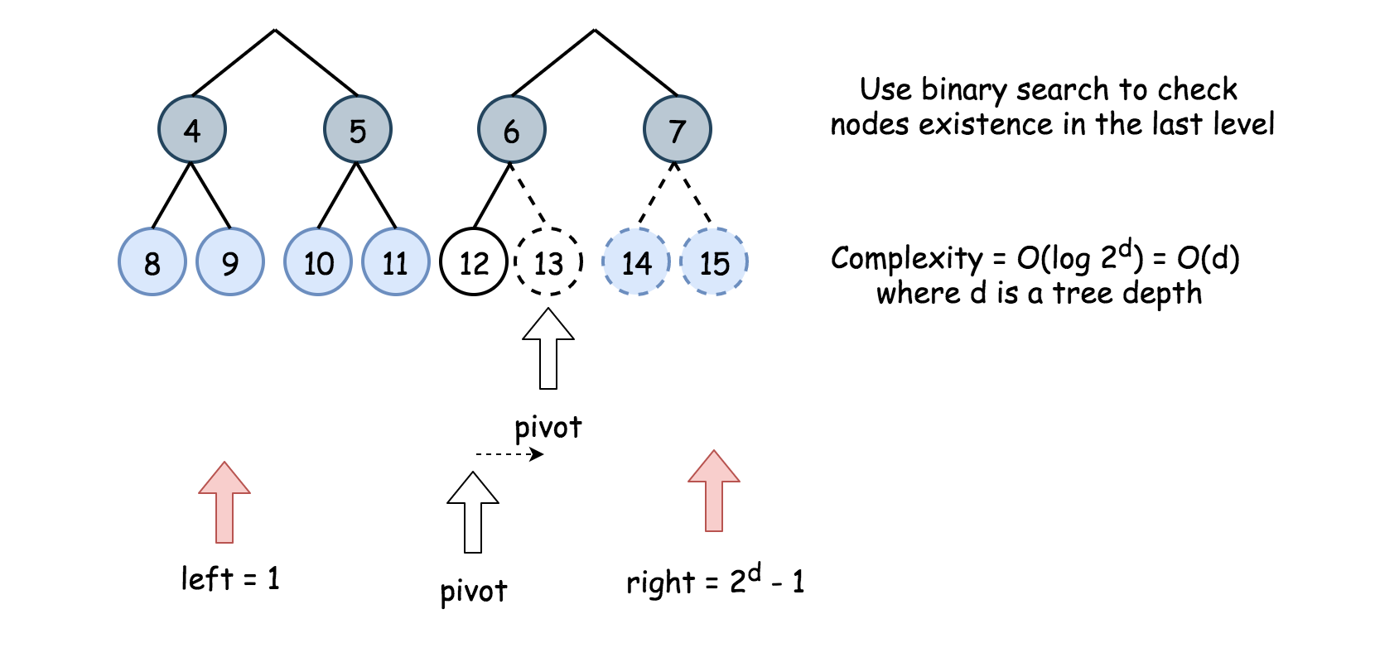

Let's move to the second question, and enumerate potential nodes in the last level from 0 to 2^d - 12*d*−1. How to check if the node number idx exists? Let's use binary search again to reconstruct the sequence of moves from root to idx node. For example, idx = 4. idx is in the second half of nodes 0,1,2,3,4,5,6,7 and hence the first move is to the right. Then idx is in the first half of nodes 4,5,6,7 and hence the second move is to the left. The idx is in the first half of nodes 4,5 and hence the next move is to the left. The time complexity for one check is \mathcal{O}(d)O(*d*).

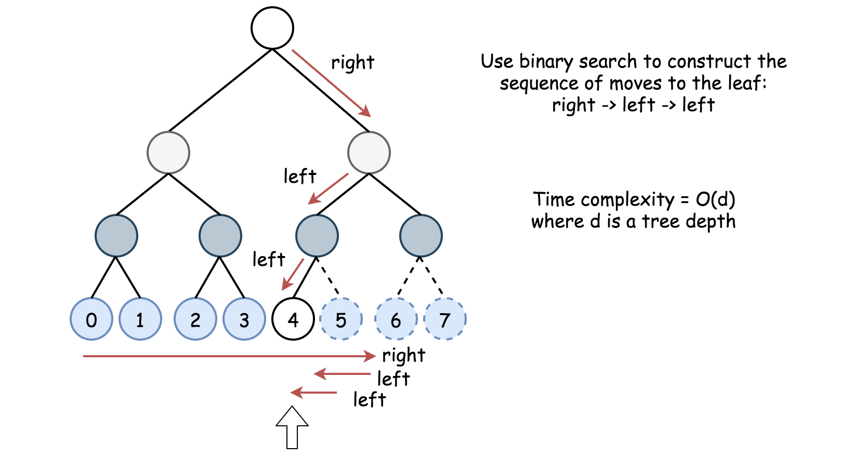

1 and 2 together result in \mathcal{O}(d)O(*d*) checks, each check at a price of \mathcal{O}(d)O(*d*). That means that the overall time complexity would be \mathcal{O}(d^2)O(*d*2).

**Algorithm**

* Return 0 if the tree is empty.
* Compute the tree depth d.
* Return 1 if d == 0.
* The number of nodes in all levels but the last one is 2^d - 12*d*−1. The number of nodes in the last level could vary from 1 to 2^d2*d*. Enumerate potential nodes from 0 to 2^d - 12*d*−1 and perform the binary search by the node index to check how many nodes are in the last level. Use the function exists(idx, d, root) to check if the node with index idx exists.
* Use binary search to implement exists(idx, d, root) as well.
* Return 2^d - 12*d*−1 + the number of nodes in the last level.

**Implementation**

class Solution {

// Return tree depth in O(d) time.

public int computeDepth(TreeNode node) {

int d = 0;

while (node.left != null) {

node = node.left;

++d;

}

return d;

}

// Last level nodes are enumerated from 0 to 2**d - 1 (left -> right).

// Return True if last level node idx exists.

// Binary search with O(d) complexity.

public boolean exists(int idx, int d, TreeNode node) {

int left = 0, right = (int)Math.pow(2, d) - 1;

int pivot;

for(int i = 0; i < d; ++i) {

pivot = left + (right - left) / 2;

if (idx <= pivot) {

node = node.left;

right = pivot;

}

else {

node = node.right;

left = pivot + 1;

}

}

return node != null;

}

public int countNodes(TreeNode root) {

// if the tree is empty

if (root == null) return 0;

int d = computeDepth(root);

// if the tree contains 1 node

if (d == 0) return 1;

// Last level nodes are enumerated from 0 to 2**d - 1 (left -> right).

// Perform binary search to check how many nodes exist.

int left = 1, right = (int)Math.pow(2, d) - 1;

int pivot;

while (left <= right) {

pivot = left + (right - left) / 2;

if (exists(pivot, d, root)) left = pivot + 1;

else right = pivot - 1;

}

// The tree contains 2**d - 1 nodes on the first (d - 1) levels

// and left nodes on the last level.

return (int)Math.pow(2, d) - 1 + left;

}

}

**Complexity Analysis**

* Time complexity : \mathcal{O}(d^2) = \mathcal{O}(\log^2 N)O(*d*2)=O(log2*N*), where d*d* is a tree depth.
* Space complexity : \mathcal{O}(1)O(1).